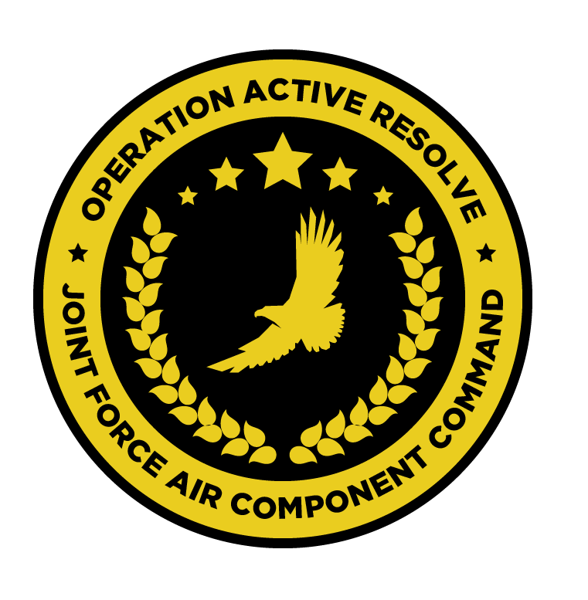

JFACC AIR OPERATIONS DIRECTIVE

OPERATION ACTIVE RESOLVE

D+2

# 1. SITUATION

## a. JFC guidance.

See [CJTF Operations Order](https://132nd-vwing.github.io/OPAR-Brief/ORDERS/OPAR%20CJTF82%20OPERATION%20ORDER.pdf)

## b. Enemy situation.

See [VIS INTSUM Ground](https://132nd-vwing.github.io/OPAR-Brief/INTELLIGENCE/INTSUM/VIS_INTSUM_D1_GROUND.pdf) and [VIS INTSUM Air](https://132nd-vwing.github.io/OPAR-Brief/INTELLIGENCE/INTSUM/VIS_INTSUM_D1_AIR.pdf)

## c. Friendly situation (by joint force component).

See [CJTF Operations Order](https://132nd-vwing.github.io/OPAR-Brief/ORDERS/OPAR%20CJTF82%20OPERATION%20ORDER.pdf) and [LCC III Corps Conops](https://132nd-vwing.github.io/OPAR-Brief/ORDERS/OPAR%20LCC%20III%20CORPS%20CONCEPT%20OF%20OPERATIONS%20PHASE%201.pdf) and [LCC IV Corps Conops](https://132nd-vwing.github.io/OPAR-Brief/ORDERS/OPAR%20LCC%20IV%20CORPS%20CONCEPT%20OF%20OPERATIONS%20PHASE%201.pdf)

# 2. MISSION - The JFACC’s mission statement (verbatim).

JFACC will establish air superiority in the area of operations and defeat Syrian offensive capability in support of CJTF-82 offensive operations to neutralize Syrian offensive capability to conduct offensives in the region.

# 3. EXECUTION – AIR OPERATIONS

|  |  |
| --- | --- |
| **JFACC’s Intent**   1. **Purpose** 2. **End State** | JFACC intends to aggressively prosecute ground-based threats to aerial operations, such that later combat sorties can focus on the destruction of Syrian ground forces in support of theatre objectives.  Additionally, efforts should continue in the support of operations at the FLOTs in both Sectors NORTH and SOUTH, such that friendly forces are easily able to engage enemy forces with minimal risk.  Excess sorties may be used in the attrition of Syrian intelligence and early warning capabilities.  The purpose of such operations is two-fold:   * To ensure the safe operation of friendly air forces * To provide direct support to friendly ground forces by attempting to attrit enemy ground forces.   The desired end state of today’s operations is such that friendly air forces can attrit enemy ground forces with greater relative safety in future combat sorties, including strikes against fixed assets. |
| **Execution** | In the execution of these missions, the AO is divided into two sectors – Sector NORTH and Sector SOUTH. These sectors are divided by the Bullseye 090 degree radial.  Operations are to be conducted at the FLOT in both Sectors NORTH and SOUTH, in addition to AI operations in support of the destruction of targets from the JPTL. |
| **Focus of effort by objective** | Three areas of focus are addressed in this AOD:  **Sector NORTH**  In this sector, the majority of effort should be directed towards the destruction of long-range SAM assets throughout the sector. It should be noted that suppression is not considered sufficient in the execution of this objective.  Some specific focus should be provided to Objective ALPHA and the attrition of air defence assets supporting the Syrian 10th Armoured Division. The destruction of MBT units should be considered a secondary objective in this AO.  **Sector SOUTH**  In this sector, the majority of effort should be directed towards the destruction of long-range SAM assets throughout the sector. It should be noted that suppression is not considered sufficient in the execution of this objective.  Some specific focus should be provided to Objective BRAVO and the attrition of air defence assets supporting the Syrian 30th Armoured Division. The destruction of MBT units should be considered a secondary objective in this AO.  **Air Interdiction**  Resources should be committed to the destruction of OPARTGT069. |
| **Allocation of sorties** | SEAD - 50%  AR – 20%  DCA – 20%  AI – 10% |
| **Acceptable level of risk**. | For SEAD missions – HIGH risk is considered acceptable  For AI missions – HIGH risk is considered acceptable.  For all other missions – MEDIUM risk is considered acceptable. |
| **Collateral damage and civilian casualty guidance** | Every attempt should be taken to minimise collateral damage in the execution of these missions. Aircrew should act in accordance with the [Law of Armed Conflict](https://www.doctrine.af.mil/Portals/61/documents/Annex_3-60/3-60-D33-Target-LOAC.pdf) at all times  Suspected civilian casualties should be reported through the C2 network as soon as is practicable. |
| **TST guidance** | Refer to SPINS/TST MATRIX (JPTL). |
| **Intelligence, Surveillance, Reconnaissance (ISR)** | All notifications of enemy air defence assets – ground- and air-based – must be reported as soon as is practicable. Reports should, where possible, include the observing aircraft’s currently position, a relative bearing to the threat and the type of threat.  Sensor taskings should be conducted where resources permit to identify the location and movements of enemy air defence assets and SCUD launchers/WMD. These locations should be reported as soon as is practicable.  Where possible, ELINT activities should be conducted to identify the locations of SAM threats. |
| **Other issues** | AWACS 502 is operational but with limited capabilities as the datalink is unserviceable. |
| **Direction and Guidance** | Aircrews must remain clear of Jordanian airspace at all times. Munitions must not be expended which may encroach on Jordanian airspace. |

# 4. ADMINISTRATION AND LOGISTICS

NSTR

# 5. COMMAND AND CONTROL

The datalink capabilities on AWACS 502 is currently unserviceable. The aircraft/service remains otherwise operational.